Network Layer Protocols

TCP/IP supports the following protocols:

ARP

* ARP stands for Address Resolution Protocol.
* It is used to associate an IP address with the MAC address.

## Each device on the network is recognized by the MAC address imprinted on the NIC. Therefore, we can say that devices need the MAC address for communication on a local area network.

## A ddress Resolution Protocol (ARP) Meaning

Address Resolution Protocol (ARP) is a protocol or procedure that connects an ever-changing Internet Protocol (IP) address to a fixed physical machine address, also known as a media access control (MAC) address, in a local-area network (LAN).

This mapping procedure is important because the lengths of the IP and MAC addresses differ, and a translation is needed so that the systems can recognize one another. The most used IP today is IP version 4 (IPv4). An IP address is 32 bits long. However, MAC addresses are 48 bits long. ARP translates the 32-bit address to 48 and vice versa.

There is a networking model known as the Open Systems Interconnection (OSI) model. First developed in the late 1970s, the [OSI model](https://www.fortinet.com/resources/cyberglossary/osi-model) uses layers to give IT teams a visualization of what is going on with a particular networking system. This can be helpful in determining which layer affects which application, device, or software installed on the network, and further, which IT or engineering professional is responsible for managing that layer.

* How ARP works

If the host wants to know the physical address of another host on its network, then it sends an ARP query packet that includes the IP address and broadcast it over the network. Every host on the network receives and processes the ARP packet, but only the intended recipient recognizes the IP address and sends back the physical address. The host holding the datagram adds the physical address to the cache memory and to the datagram header, then sends back to the sender.

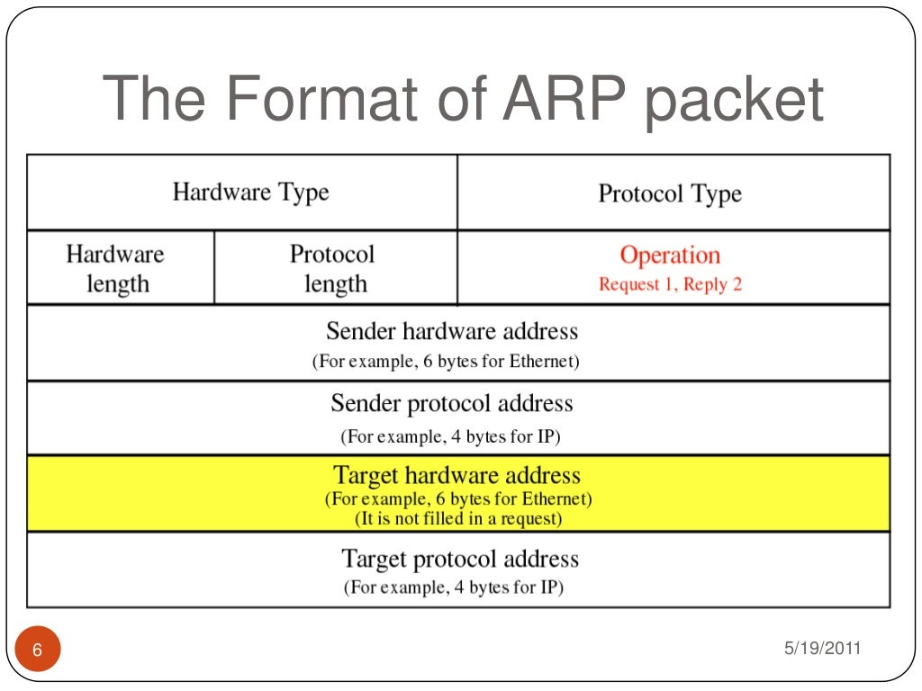

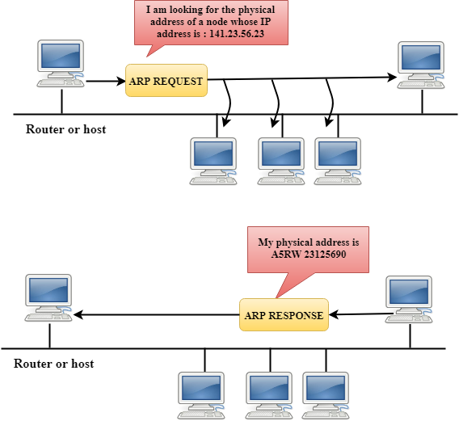

Steps taken by ARP protocol

If a device wants to communicate with another device, the following steps are taken by the device:

* The device will first look at its internet list, called the ARP cache to check whether an IP address contains a matching MAC address or not. It will check the ARP cache in command prompt by using a command **arp-a**.
* If ARP cache is empty, then device broadcast the message to the entire network asking each device for a matching MAC address.
* The device that has the matching IP address will then respond back to the sender with its MAC address
* Once the MAC address is received by the device, then the communication can take place between two devices.
* If the device receives the MAC address, then the MAC address gets stored in the ARP cache. We can check the ARP cache in command prompt by using a command arp -a.

Note: ARP cache is used to make a network more efficient.

There are two types of ARP entries:

* **Dynamic entry:** It is an entry which is created automatically when the sender broadcast its message to the entire network. Dynamic entries are not permanent, and they are removed periodically.
* **Static entry:** It is an entry where someone manually enters the IP to MAC address association by using the ARP command utility.

RARP

* RARP stands for **Reverse Address Resolution Protocol**.
* If the host wants to know its IP address, then it broadcast the RARP query packet that contains its physical address to the entire network. A RARP server on the network recognizes the RARP packet and responds back with the host IP address.
* The protocol which is used to obtain the IP address from a server is known as **Reverse Address Resolution Protocol**.
* The message format of the RARP protocol is similar to the ARP protocol.
* Like ARP frame, RARP frame is sent from one machine to another encapsulated in the data portion of a frame.

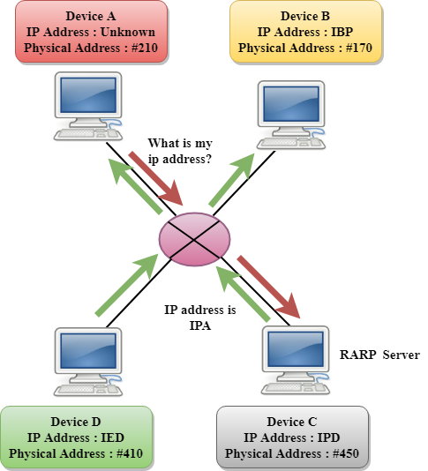

ICMP

* ICMP stands for Internet Control Message Protocol.
* The ICMP is a network layer protocol used by hosts and routers to send the notifications of IP datagram problems back to the sender.
* ICMP uses echo test/reply to check whether the destination is reachable and responding.
* ICMP handles both control and error messages, but its main function is to report the error but not to correct them.
* An IP datagram contains the addresses of both source and destination, but it does not know the address of the previous router through which it has been passed. Due to this reason, ICMP can only send the messages to the source, but not to the immediate routers.
* ICMP protocol communicates the error messages to the sender. ICMP messages cause the errors to be returned back to the user processes.
* ICMP messages are transmitted within IP datagram.

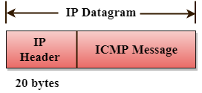

The Format of an ICMP message

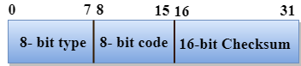

* The first field specifies the type of the message.
* The second field specifies the reason for a particular message type.
* The checksum field covers the entire ICMP message.

Error Reporting

ICMP protocol reports the error messages to the sender.

**Five types of errors are handled by the ICMP protocol:**

* Destination unreachable
* Source Quench
* Time Exceeded
* Parameter problems
* Redirection

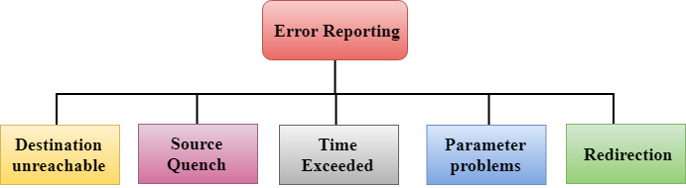

* **Destination unreachable:** The message of "Destination Unreachable" is sent from receiver to the sender when destination cannot be reached, or packet is discarded when the destination is not reachable.
* **Source Quench:** The purpose of the source quench message is congestion control. The message sent from the congested router to the source host to reduce the transmission rate. ICMP will take the IP of the discarded packet and then add the source quench message to the IP datagram to inform the source host to reduce its transmission rate. The source host will reduce the transmission rate so that the router will be free from congestion.
* **Time Exceeded:** Time Exceeded is also known as "Time-To-Live". It is a parameter that defines how long a packet should live before it would be discarded.

IGMP

* IGMP stands for **Internet Group Message Protocol**.
* The IP protocol supports two types of communication:
  + **Unicasting:** It is a communication between one sender and one receiver. Therefore, we can say that it is one-to-one communication.
  + **Multicasting:** Sometimes the sender wants to send the same message to a large number of receivers simultaneously. This process is known as multicasting which has one-to-many communication.
* The IGMP protocol is used by the hosts and router to support multicasting.
* The IGMP protocol is used by the hosts and router to identify the hosts in a LAN that are the members of a group.

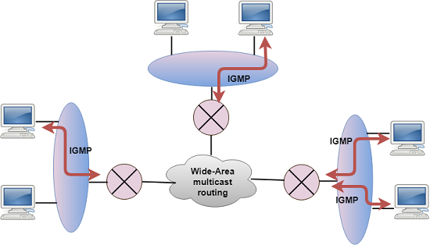

* IGMP is a part of the IP layer, and IGMP has a fixed-size message.
* The IGMP message is encapsulated within an IP datagram.

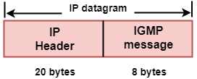

The Format of IGMP message

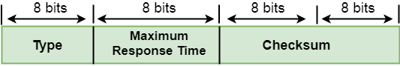

# Dynamic Host Configuration Protocol

Dynamic Host Configuration Protocol (DHCP) is a network management protocol used to dynamically assign an IP address to nay device, or node, on a network so they can communicate using IP (Internet Protocol). DHCP automates and centrally manages these configurations. There is no need to manually assign IP addresses to new devices. Therefore, there is no requirement for any user configuration to connect to a DHCP based network.

DHCP can be implemented on local networks as well as large enterprise networks. DHCP is the default protocol used by the most routers and networking equipment. DHCP is also called RFC (Request for comments) 2131.

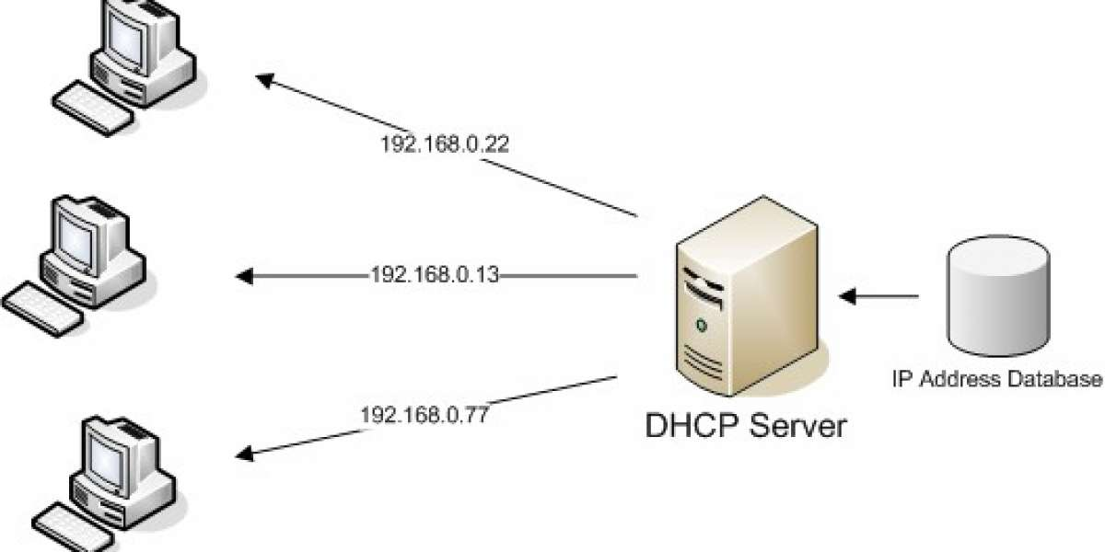

The DHCP lease process works as follows:

* First of all, a client (network device) must be connected to the internet.
* DHCP clients request an IP address. Typically, client broadcasts a query for this information.
* DHCP server responds to the client request by providing IP server address and other configuration information. This configuration information also includes time period, called a lease, for which the allocation is valid.
* When refreshing an assignment, a DHCP clients request the same parameters, but the DHCP server may assign a new IP address. This is based on the policies set by the administrator.